Lab 3
In this lab, you’ll update the code from the starter file lab3.py. You only need to submit this updated file.

Step 0
- Download the file lab3.zip. Unzip and save all three files in the same folder.
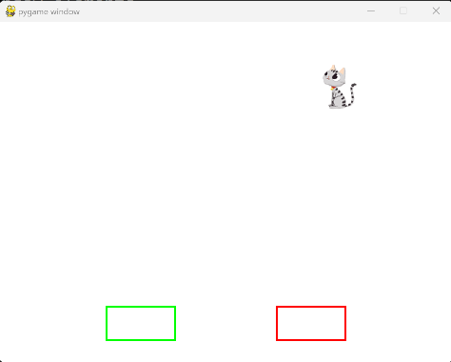
- Run the lab3.py code to test if your image and sound files are in the correct folder. If you have errors, fix them before continuing.
  - The program will display the following window:
  - The cat may appear in a random position.
- Read the code to understand what it is doing.

Goal
- As you may have noticed, the program does not respond to keyboard or mouse events, except for the close button (x).
- The goal of the lab is to make the program handle certain mouse and keyboard events.
- You will not make changes to the CatImage class.
  - Do not change the path to the image and sound files (both must be only the file name).
- You will add/update code in the main section of the program. Some #TODO sections are marked to indicate where new code is needed.
  - You should use methods already defined in the CatImage class.
- Work on each step below and test your code after every step.

Step 1
- When the rectangle on the left (with the green outline) is clicked, add a new cat image to the window (and to the list of cats).

Step 2

When the rectangle on the right (with the red outline) is clicked, remove the last cat added from the screen (and list of cats).

When the rectangle is clicked but there are no cats to remove, give the user feedback by playing the boing.wav sound. Do not allow your program to crash.

Step 3
- When any cat is clicked, move that cat to a random position in the window. Hint: call a method from the CatImage class.

Step 4
- When a cat and any rectangle overlap, the rectangle must appear on top, that is, the cat must not cover the rectangle outline.
- When a click happens on any overlapping objects, all objects under the mouse pointer must detect and respond to the click.

Step 5
- When the user presses the arrow keys on the keyboard, move only one cat (the last cat added) accordingly.
  - Your program should keep moving the cat if the key is pressed continuously.
  - If more than one arrow is pressed the program must detect all pressed keys and move accordingly. For example, if the user holds the up and right arrow keys at the same time, the cat must move diagonally.

Step 6
- Prevent the cat from going outside of the window boundaries when the user is moving it with the keyboard.
  - When the cat touches the "wall", it must stop moving. Play a short sound to indicate a collision with the wall.

Submit your program on Canvas.
- Don’t forget to test your code thoroughly.
  - Make sure your paths to the external files (image and sound) do not contain any folder name. They should be only the file name, just like provided in the starter code, or it will not work when we test.
- Submit only the file lab3.py
  - You do not need to submit the image or the sound file.

